**DATA ANALYSIS**

**PROJECT**

**ON NETFLIX MOVIES**

* **Exploratory data analysis (EDA)**

**using Python on Jupyter Notebook**

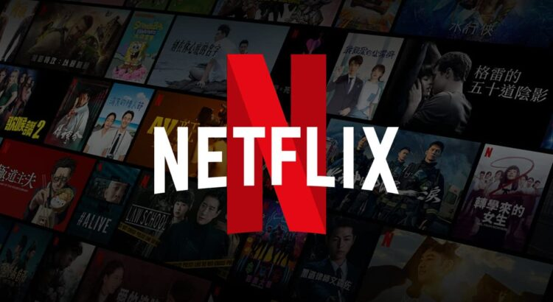

**Netflix Movies Data Analysis – Exploratory Data Analysis (EDA)**

Welcome to my EDA project on Netflix movies! This project dives deep into Netflix’s content to understand trends, viewer preferences, and key factors behind movie success on the platform.

**Project Overview:**

With streaming services like Netflix revolutionizing how we consume entertainment, this project focuses on analyzing movie data to answer key questions and generate insights. Using Python and popular data science libraries, the analysis includes data cleaning, visualizations, and trend analysis.

**Tech Stack & Tools:**

* Jupyter Notebook
* Python
* Pandas
* NumPy
* Matplotlib
* Seaborn

**Key Components:**

1. Data Collection & Cleaning-

* Imported Netflix movie dataset
* Handled missing values
* Standardized formats (dates, genres, etc.)

2. Exploratory Data Analysis (EDA)-

* Identified trends and patterns in genres, release years, popularity, and ratings
* Created summary statistics and pivot tables

3. Visualizations-

* Used Seaborn and Matplotlib for:
  + Bar plots
  + Count plots
  + Line graphs
  + Histograms
* Designed visual insights for better interpretation

4. Insights & Takeaways-

* Shared key insights and observations at the end of the notebook
* Discussed implications for content curation and user preferences

Questions Explored:

1. What is the most frequent genre of movies released on Netflix?
2. Which genre has the highest average vote?
3. Which movie has the highest popularity? What is its genre?
4. Which movie has the lowest popularity? What is its genre?
5. Which year had the most movie releases on Netflix?